Agreement between Agencies on matters relating to the implementation of the National Environment Protection (Movement of Controlled Waste between States and Territories) Measure
Jurisdictions agree to act in good faith to implement the matters contained within this Agreement. Jurisdictions recognise that implementation is subject to supporting legislation being in place in each jurisdiction.
An agreement made the 1st day of May two thousand and seventeen
BETWEEN THE FOLLOWING PARTIES
Barry Buffier, for and on behalf of the New South Wales Environment Protection Authority
Mr Nial Finegan, for and on behalf of Environment Protection Authority of Victoria
Mr Jim Reeves, for and on behalf of Department for Environment and Protection of Queensland
Mr Dan Volaric, for and on behalf of the Department of Environment Regulation Western Australia
Mr Tony Circelli, for and on behalf of the Environment Protection Authority of South Australia
Mr Wes Ford, for and on behalf of the Department of Primary Industries, Parks, Water and Environment of Tasmania
Ms Jo Townsend for and on behalf of the Department of Environment and Natural Resources, Northern Territory
Mr Ben Ponton, for and on behalf of the Environment, Planning and Sustainable Development Directorate, Australian Capital Territory
The National Environment Protection (Movement of Controlled Waste between States and Territories) Measure (“the Measure”) provides a basis for ensuring that controlled wastes which are to be moved between States and Territories are properly identified, transported and otherwise handled in ways which are consistent with environmentally sound practices for the management of these wastes.
This Agreement sets out the administrative matters on which agreement between jurisdictions is required in order to facilitate a cooperative and integrated approach to implementation of the Measure throughout Australia. Key features of this Agreement are the mutual recognition of waste transport licences for the purposes of controlled waste movements between States and Territories, and the development of a national tracking system.
Transport of controlled wastes under the mutual recognition of licences (as per the definition for licences in the Measure) provided for in this Agreement will ensure that a common set of licence outcomes is applied throughout Australia. The tracking system procedures outlined in the Agreement will assist agencies in ensuring that controlled wastes are directed to and reach appropriate facilities, and will provide important information to emergency services in the event of an accident or spill.
This Agreement should be read together with the Measure to provide the necessary detail or processes in relation to implementation of the Measure. The Agreement is complementary to and in no way replaces any part of the Measure.
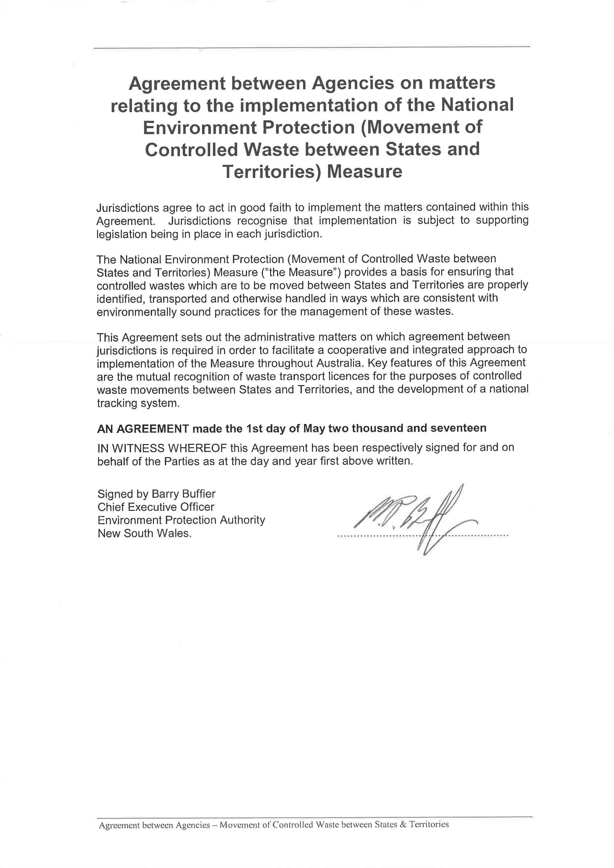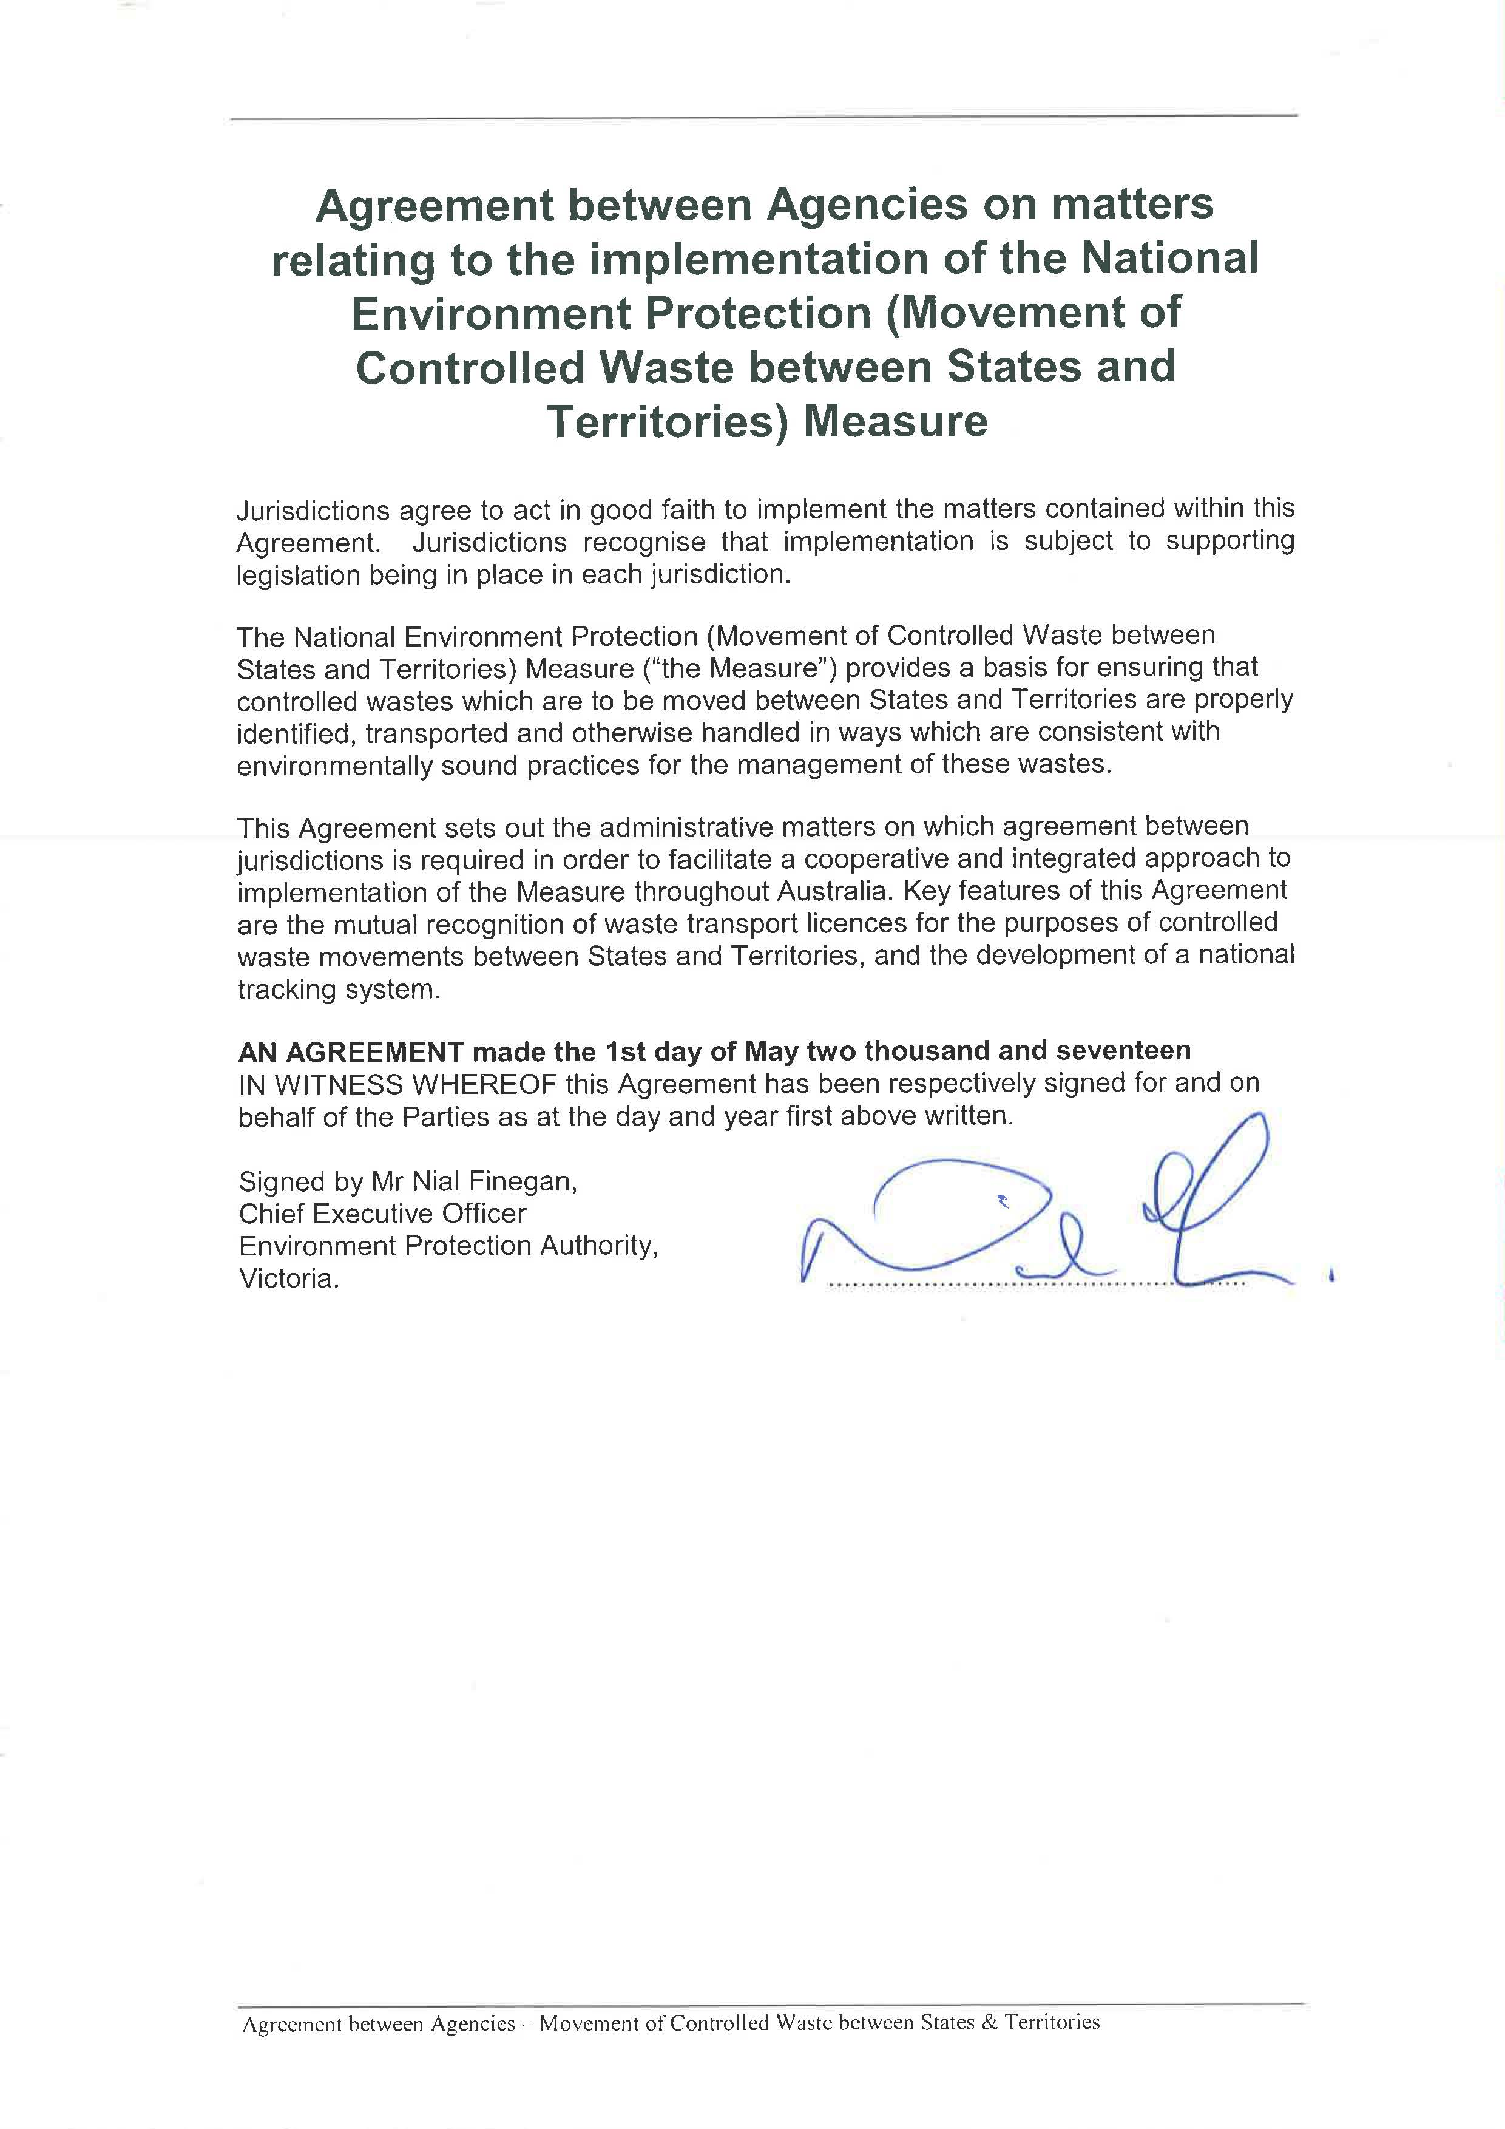
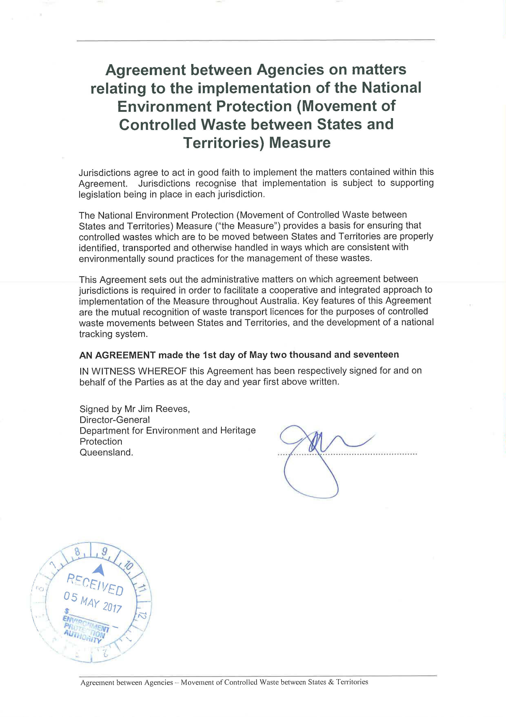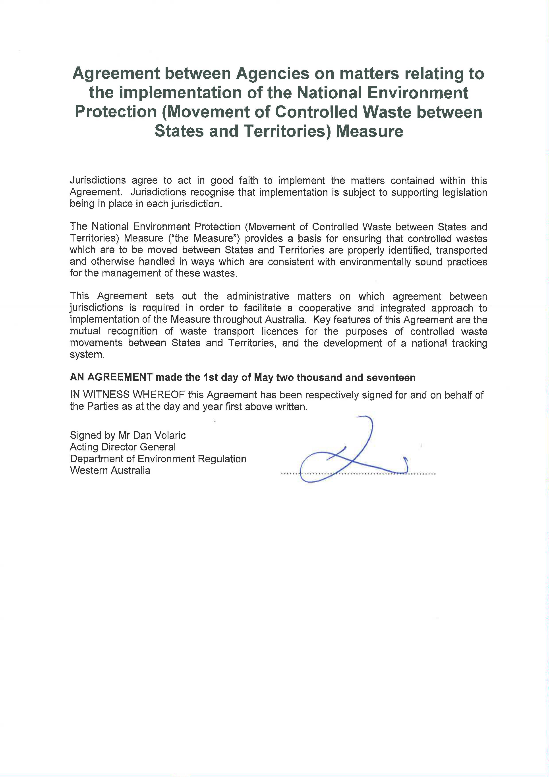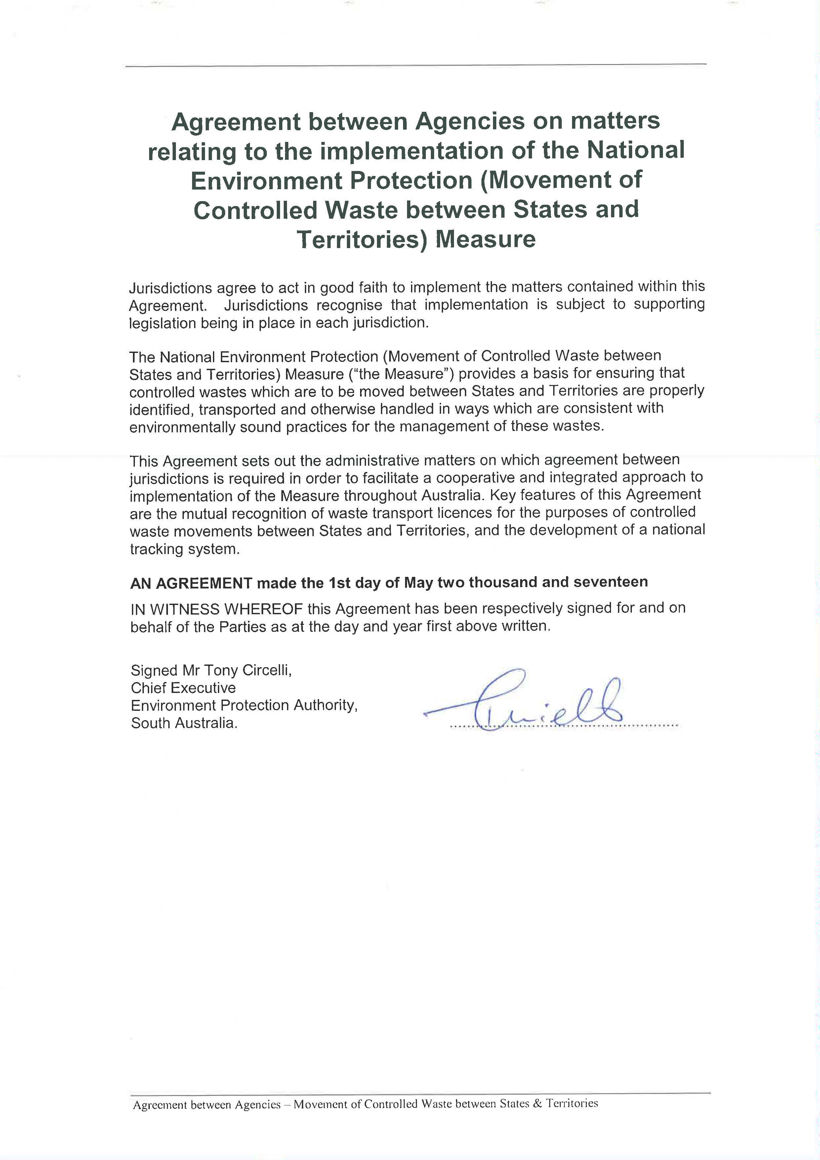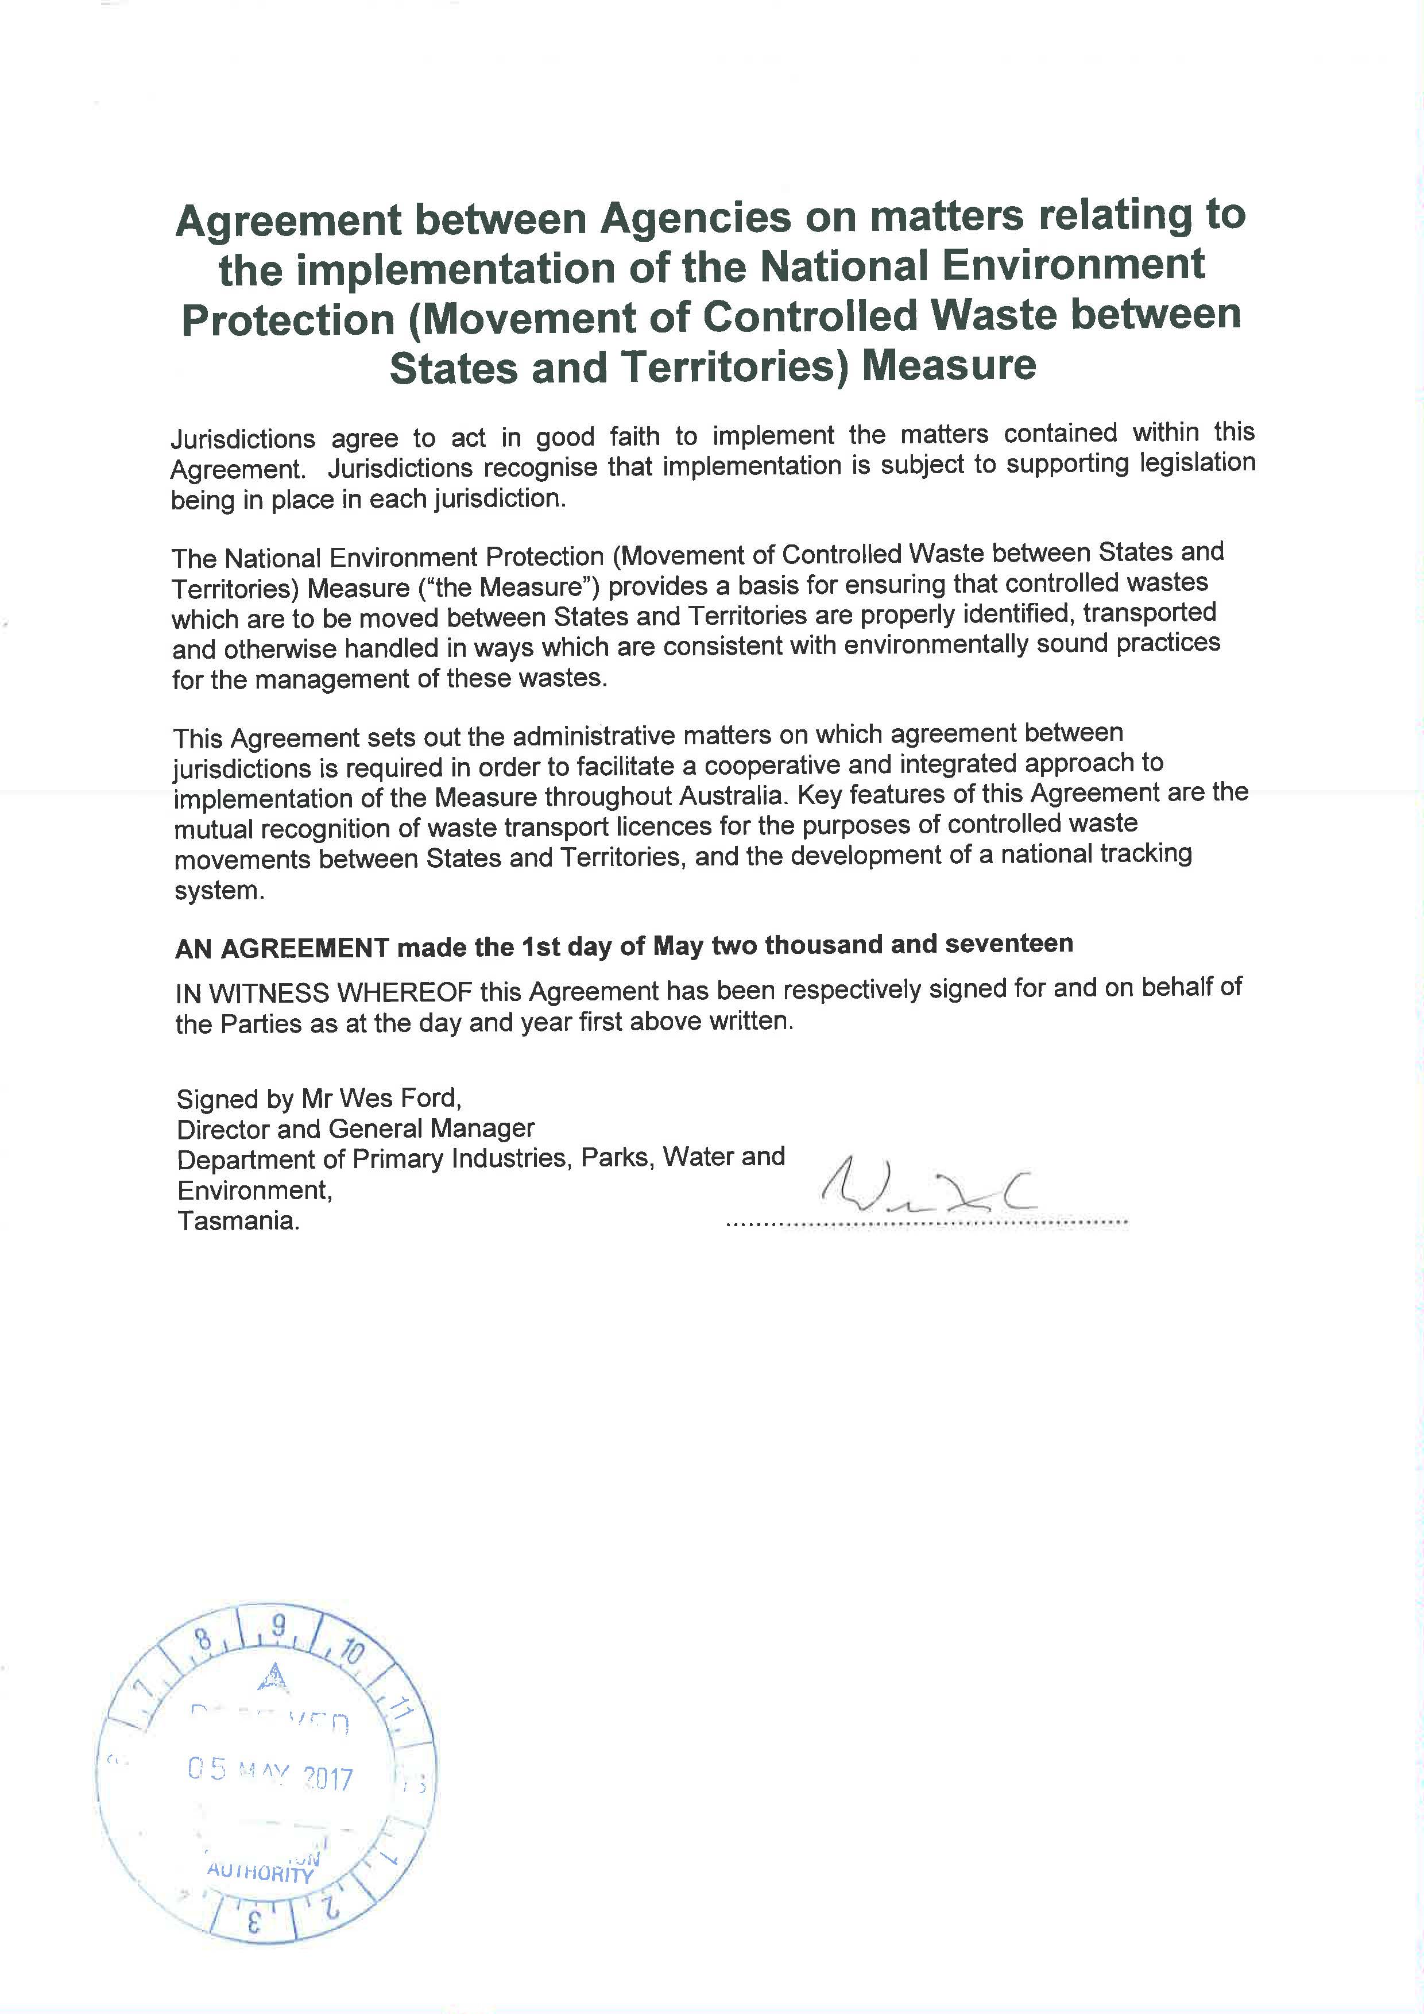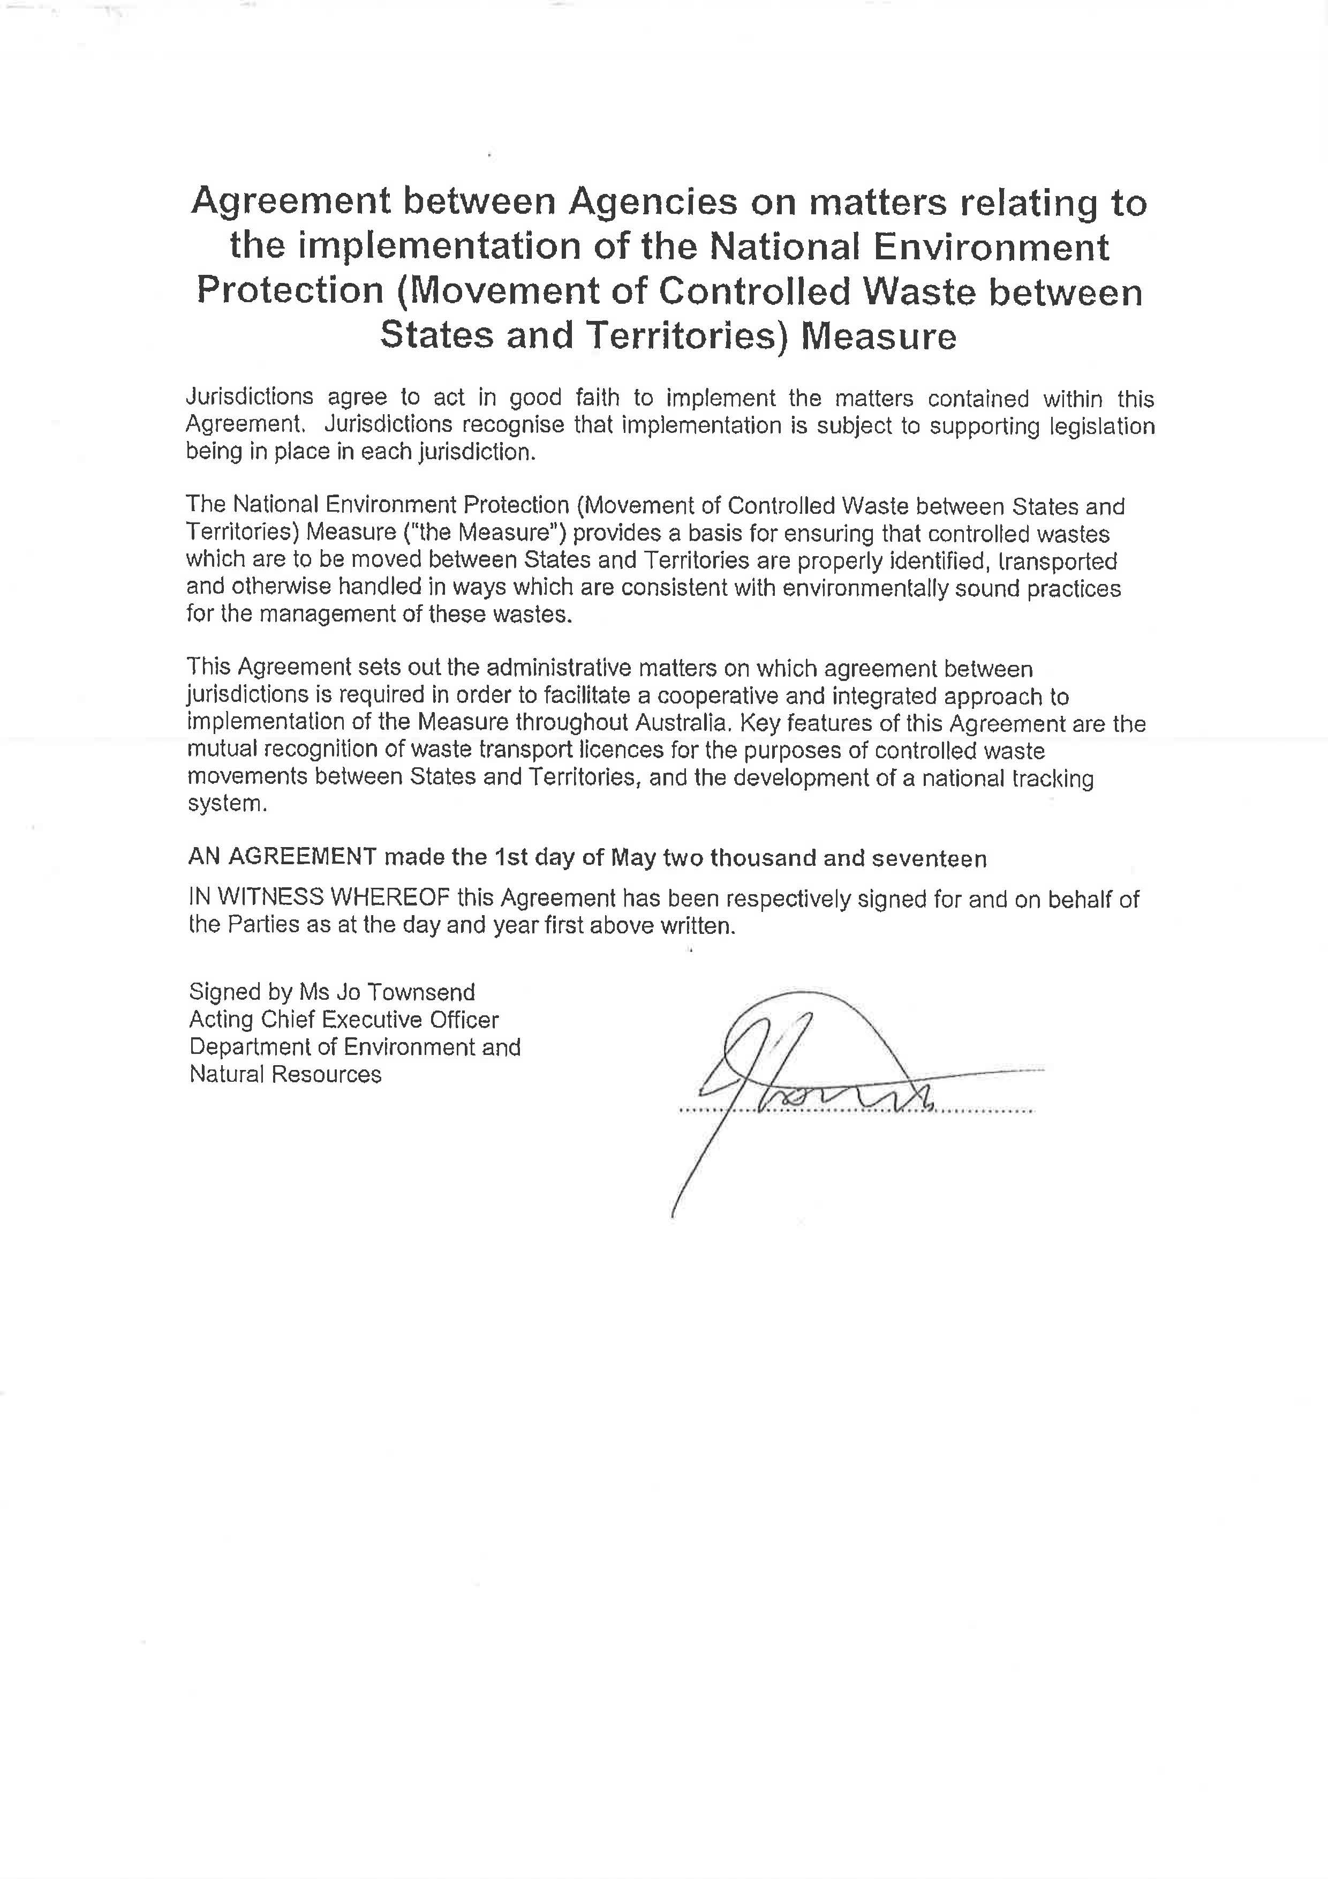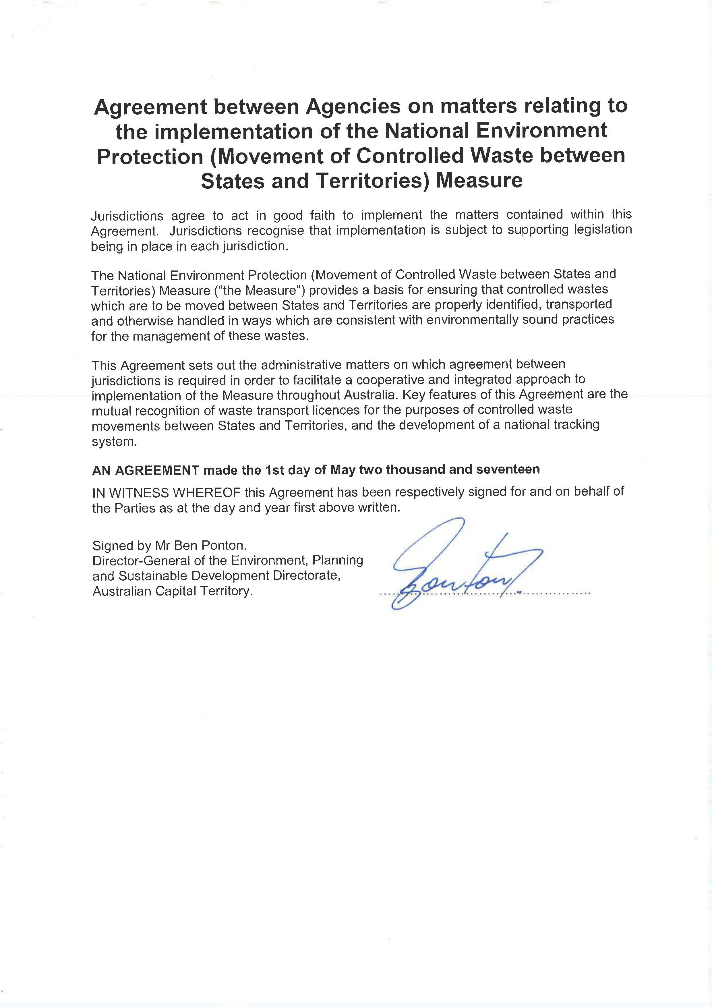

Now it is agreed as follows:
- Operation
  - This Agreement will come into force upon signature, and will continue until revoked or amended.
  - This Agreement may only be amended or revoked by the agreement of all Chief Executive Officers or nominated delegate of the nominated agencies (or their successor bodies) who are signatories to this agreement.
  - An Implementation Working Group, consisting of one representative; nominated by each Chief Executive Officer or nominated delegate will continue to assist with the implementation of this Agreement and of the Measure.
  - The Implementation Working Group will operate according to the terms of reference as set out in Schedule 3 of this Agreement. Each Party will ensure that sufficient resources are provided so that the Implementation Working Group can meet once each year.
- Interpretation
  - In this Agreement:
“Agreement” means the Agreement between nominated Agencies for the implementation of the National Environment Protection (Movement of Controlled Wastes between States and Territories) Measure.
“Chief Executive Officer” means the chief executive, director-general, general manager, secretary, director, head, chair, or other similar level representative of a nominated agency.
“Delegated facility” means a facility licensed by a nominated agency to issue consignment authorisations for the purposes of the Measure.
“Measure” means the National Environment Protection (Movement of Controlled Wastes between States and Territories) Measure 1998.
“NEPC” means National Environment Protection Council.

“Nominated agency” means the agency of a participating State or Territory, which that State or Territory has nominated as having responsibility for implementation of the National Environment Protection (Movement of Controlled Wastes between States and Territories) Measure.
“Nominated delegate” means the person who is appointed, authorised, delegated, or commissioned to act in the place of another on behalf of the agency.
“Party” means any of the signatories to this Agreement, or an officer of a nominated agency delegated by a signatory to act on his or her behalf.
  - Other words used in the Agreement shall, so far as is applicable, have the same meanings as defined in the National Environment Protection Council Act 1994, and the National Environment Protection (Movement of Controlled Wastes between States and Territories) Measure 1998.
- Scope
  - This Agreement establishes the basis on which the Parties will work cooperatively to implement the Measure.
  - This Agreement allows for the future inclusion, deletion and amendment of schedules, mechanisms, and guidelines for the implementation of the Measure which are agreed by all Parties.
- Schedules
The Schedules are a part of this Agreement.
- ARRANGEMENTS FOR IMPLEMENTATION OF THE MEASURE
  - Mutual Recognition of Waste Transport Licences
    - For the purposes of fulfilling the licensing and mutual recognition requirements of clause 13 of the Measure, a licence as defined by the Measure granted in a participating State or Territory to a transporter established for the conduct of business in that jurisdiction shall be recognised for the purpose of the Measure in each other participating State or Territory subject to the required jurisdictional legislation.
    - Mutual recognition as defined in 5.1.1 shall not be construed to mean the recognition of a licence for the purpose of the intrastate transport of controlled wastes within another jurisdiction.
    - A licence issued by a participating State or Territory will be recognised for the purposes of clause 13 (a) and (b) of the Measure, if a licence under which controlled wastes are transported between States and Territories includes the matters set out in Schedule 1 of this Agreement.
  - Information Sharing
    - Confidentiality of Information Exchanged between Jurisdictions
      - Subject to clause 15 of the Measure and the existing legal requirements of each jurisdiction, the Parties in dealing with applications for access to information supplied by agencies, consignors, producers, transporters, and facilities of other jurisdictions, will notify the nominated agency of any other relevant jurisdiction of the existence of such applications prior to making a determination, and advise on the outcome of any such determination.
      - The Parties will share and exchange generic information on their assessments of claims for commercial confidentiality with the intention of encouraging consistency of approach in different jurisdictions, as far as is practicable.
    - Enforcement
      - The Parties will provide information to the relevant nominated agencies on infringement notices issued, prosecutions undertaken, and convictions relating to any person or company engaged in the transport of controlled wastes between States and Territories.
      - Where deemed appropriate by nominated agencies the affected Parties will exchange information and otherwise cooperate in taking appropriate action against transporters established in other jurisdictions suspected of violations of the Measure.
      - A Party will advise all other Parties within 28 calendar days if it revokes, suspends or restricts a waste transport licence issued in its jurisdiction, or if it revokes, suspends or restricts a licence previously recognised as valid in its jurisdiction for the purposes of the Measure.
(Note: A party may meet the requirements of 5.2.2 of this agreement by publication of information online.)
    - Waste Tracking Procedures
      - The Parties will exchange information necessary to ensure that wastes transported between jurisdictions under a valid consignment authorisation are effectively tracked.
      - The Parties agree to implement the waste tracking procedures set out in Schedule 2 subject to the required jurisdictional legislation being put in place.

Schedule 1
Outcomes to be met by jurisdictional licenses for the purpose of interstate transport of controlled wastes

General Requirements Relating to Controlled Wastes

A licence under which controlled wastes are transported between States and Territories must deliver the following outcomes.
- A copy of the appropriate waste transport licence, authorisation, permit, notice, or approval granted by the nominated agency of the State or Territory in which the transporter is established for business purposes must be carried in the vehicle at all times.
- The applicable information as required by Part 1 and Part 2, Schedule B of the Measure must be carried for the current consignment in printed hard copy form or approved electronic form in the vehicle each time that it is engaged in the transportation of controlled waste under the Measure.
- Documentation referred to in conditions 1, and 2, above must be carried in the cabin of the vehicle in accordance with the requirements of the latest edition of the Australian Dangerous Goods Code, and must be presented on demand to an authorised officer of the nominated agency of the State or Territory in which the vehicle is travelling.
- A copy of the current certificate of registration for each vehicle used under a waste transport licence must be provided on demand to the nominated agency of any State or Territory in or through which a consignment of waste is moved by the transporter under the Measure.
- The transporter must retain a record of the applicable information as required under Schedule B of the Measure for at least 12 months (or for any longer period as required by the nominated agency of the State or Territory which issued the waste transporter licence) from the date of transport for each controlled waste shipment.

  - Nominated agencies may exempt transporters from the requirement to hold records where such records are stored in approved electronic system.
- Vehicles and waste containers must be suitably constructed, maintained, secured and operated at all times so as to prevent any spillage or release of controlled waste to the environment, risk to human health, or offensive condition. Controlled waste must only be transported in properly designed containers or bins on the vehicle.
- Recovery and clean-up of spilt, leaked, escaped or any other loss of controlled waste must be promptly carried out to prevent pollution, environmental harm or risk to human health.

- Any spillage, leak, escape or other loss of controlled waste must be reported as soon as practicable to the appropriate agency of the State or Territory in which the vehicle is traveling when the incident occurs.
- Incompatible wastes must not be mixed. In general wastes are incompatible if when mixed or otherwise brought into contact, they are likely to interact and increase the risk to human health and/or the environment. If a waste is classified as a dangerous good, the latest edition of the Australian Dangerous Goods Code relating to the mixing of incompatible goods must be observed. Notwithstanding the above, for the purpose of the Measure, mixing incompatible wastes also includes mixing of incompatible liquids and mixing solid waste with liquid waste.
- A vehicle used for the transport of liquid controlled waste must have suitable sampling points on the top of each compartment, and where appropriate, additional sampling valve(s) must be provided at the bottom of the container. Sampling points must be readily accessible for the purposes of roadside inspection.
- The movement of a controlled waste classified as dangerous goods under the latest edition of the Australian Dangerous Goods Code must comply with the requirements of that code (or a State or Territory regulation requiring equivalent standards) in addition to any other requirement imposed by the Measure.
- A transporter of controlled waste under the Measure must comply with any additional requirement imposed as a condition of a consignment authorisation by the nominated agency of the State or Territory of destination.

Special Requirements Relating to Particular Controlled Wastes

Clinical and Related Wastes
- Packaging of all clinical and related wastes must conform to the Australian Standard for the Management of Clinical and Related Waste.
- Clinical and related wastes are only to be transported in a totally enclosed leak proof and lockable compartment, the walls and floor of which are to be as seamless as possible to facilitate cleaning and disinfection before reuse.
- Vehicles without secondary containment are to be fitted with a bunding and sump system to prevent spills and leaks at all times.
- Clinical and related wastes must not be transported in vehicles fitted with compaction systems.
- Vehicles must be securely locked when unattended.
- Vehicles must carry a spill management and driver safety kit, as specified in the Australian Standard for the Management of Clinical and Related Waste.

Polychlorinated Biphenyls (PCBs)
- A vehicle transporting controlled waste contaminated with PCBs and classified as Scheduled Wastes under the PCB Management Plan issued by ANZECC must comply with the requirements of that Plan. In particular, the vehicle must carry personnel suitably trained in methods of containing spilled PCBs, and be provided with appropriate personal protective equipment, clean up material and equipment to deal with any spill.
Asbestos

- Persons transporting controlled waste contaminated with asbestos between States and Territories must ensure the waste is packaged in accordance with the latest edition of the National ‘Code of Practice on how to safely remove asbestos’ April 2016 and all other regulatory requirements relating to asbestos imposed by the relevant authority of the State or Territory in which the transporter is licensed.

E-Waste

- Persons transporting controlled waste contaminated with e-waste between States and Territories must ensure the waste is packaged in accordance with the Australian and New Zealand Standard ‘AS/NZS 5377:2013 Collection, storage, transport and treatment of end-of-life electrical and electronic equipment’ which outlines the minimum requirements for the safe and environmentally sound handling of e-waste.

Schedule 2
Tracking System Procedures for the Transport of Controlled Wastes between States and Territories
Part 1 Responsibilities of Waste Producers

The Measure defines controlled waste as “any waste in List 1 provided that the waste possesses one or more of the characteristics in List 2. Unless otherwise demonstrated to the satisfaction of the nominated agency in the jurisdiction of destination, all wastes in List 1 are considered to possess one or more characteristics in List 2.”

- It is the responsibility of the producer of a controlled waste (or agent where the agent has been authorised to act on behalf of multiple producers) to obtain a consignment authorisation from the nominated agency or delegated facility in the State or Territory of destination. The producer or agent must not allow controlled wastes to leave its premises unless a valid consignment authorisation has been issued for that waste.

- The controlled waste producer must provide to the transporter in printed hard copy or approved electronic form all applicable information as required by Part 1, Schedule B of the Measure. The required documentation and format for Schedule B information will be determined by the nominated agency in the State or Territory of destination.

- The controlled waste producer must retain a hard copy or approved electronic form of all applicable Schedule B information for at least 12 months from the date of dispatch of each consignment.
(Note: The State or Territory in which the controlled waste producer is established may require that information be retained for a period greater than 12 months.)
- The controlled waste producer must confirm that the controlled waste transporter is appropriately licensed in a participating State or Territory.
(Note: A transporter is required to carry on each vehicle a hard copy form or approved electronic form of the waste transport licence issued by the nominated agency of the State or Territory in which the transporter is established for business purposes.)

The controlled waste producer must report the dispatch of each consignment to:
  - the nominated agency or the delegated facility in the State or Territory of destination; and
  - the nominated agency in the State or Territory of origin.
- Where required by the nominated agency of the State or Territory of origin, controlled waste producers must provide exception reports to the nominated agency if they do not receive written confirmation of receipt within 14 working days from the destination facility to which a consignment was dispatched.
(Note: The means of “reporting” the dispatch of a controlled waste consignment may vary depending on the requirements of the State or Territory of destination. Where a docket system is used, reporting consists of sending the relevant docket to the nominated agency within the time period specified. If the agency in the State or Territory of destination use an electronic system, ensuring details of receipt are entered into that system may be sufficient. Where periodic reporting is used, normal reporting will consist of providing aggregated returns as required by the nominated agency of the State or Territory of origin.)

- A waste producer of controlled waste under the Measure must obtain and comply with any approval required by the State or Territory of origin.

Schedule 2
Tracking System Procedures for the Transport of Controlled Wastes between States and Territories
Part 2 Responsibilities of Waste Transporters

- The transporter must ensure that the waste transport licence held is suitable for the purpose of interstate transport under the Measure.
(Note: If necessary, the nominated agency in the State or Territory in which the transporter is established for business purposes should be contacted to clarify status of a licence.)
- The transporter must provide or confirm to the controlled waste producer at time of pick up, the applicable information as required by Part 2, Schedule B of the Measure.

- The transporter must ensure that all necessary documentation is kept in a suitable emergency information holder. The required information includes:
  - a printed hard copy of all applicable Part 1 and Part 2 Schedule B information
  - the relevant waste transport licence (original or copy)
  - an appropriate emergency procedure guide

(Note: All three items of documentation must be carried at all times in the cabin of the vehicle and must be presented on demand to an authorised officer of an agency of the State or Territory in which the vehicle is travelling.)

- The transporter must retain a copy of the applicable Schedule B information for at least 12 months from the date of transport of each consignment.

  - Nominated agencies may exempt transporters from the requirement to hold records where such records are stored in an approved electronic system.

- The transporter must ensure that a copy of the applicable Schedule B information is provided to the receiving facility on delivery of the consignment.
- The transporter must obtain written proof of receipt of a consignment from the facility on delivery.
  - Nominated agencies may exempt transporters from the requirement to obtain written proof of receipt of a consignment where such records are stored in approved electronic system
(Note: What constitutes acceptable “written proof of receipt” may vary depending on the requirements of the nominated agency of the State or Territory of destination; where a 5 docket system is in use, the signing of the relevant docket may be sufficient. If the agency in the State or Territory of destination use an electronic system, the entering of details of receipt into that system may be sufficient)

- If a facility refuses to accept a controlled waste load for any reason, the transporter must immediately notify the nominated agency of the State or Territory in which the facility is located.

Additional responsibilities where more than one transporter is involved in a controlled waste shipment

- Whenever more than one transporter is involved in moving controlled waste from a producer to a facility, each time the responsibility and control for the waste is transferred, each party must obtain a written receipt or an electronic record from the other, noting consignment authorisation number, date, time and location of the hand over. All parties must retain these receipts for at least 12 months, as they form part of the information required by Schedule B of the Measure. This requirement applies to all parties sub-contracted by the transporter.

  - Nominated agencies may exempt transporters from the requirement to obtain written proof of receipt of a consignment where such records are stored in an approved electronic system.
(Note: What constitutes an acceptable “written receipt” may vary depending on the requirements of the State or Territory of destination; where a 5 docket system is in use, an appropriate notation on the relevant docket may be sufficient provided this is approved by the nominated agency. If the agency in the State or Territory of destination use an electronic system, the entering of details of receipt into that system may be sufficient)

Schedule 2
Tracking System Procedures for the Transport of Controlled Wastes between States and Territories
Part 3 Responsibilities of Waste Facilities

- On receiving controlled waste, the facility must obtain a hard copy form or approved electronic form of the applicable Schedule B information from the transporter and after checking consignment details and issue a written receipt.
(Note: What constitutes an acceptable “written receipt” may vary depending on the requirements of the nominated agency of the State or Territory of destination; where a 5 docket system is in use, the signing of the relevant docket may be sufficient. If the agency in the State or Territory of destination use an electronic system, the entering of details of receipt into that system may be sufficient)

- The facility must report the receipt of a consignment to:
  - the producer;
  - the nominated agency in the jurisdiction of origin on receipt of each consignment;
  - the nominated agency in the jurisdiction of destination on receipt of each consignment.

(Note: The means of “reporting” receipt of controlled waste may vary depending on the requirements of the State or Territory of destination. Where a docket system is used, reporting consists in sending the relevant docket to the nominated agency. If the agency in the State or Territory of destination use an electronic system, reporting consists of ensuring details of receipt are entered into that system)

- The facility must provide the information required by Part 3 of Schedule B and retain a hard copy form or approved electronic form of all applicable Schedule B information relating to each consignment for at least 12 months from the date of receipt.
(Note: The State or Territory in which the waste facility is located may require that information be retained for a period greater than 12 months.)
- The facility must report any discrepancies between the information provided in Parts 1 and 2 of Schedule B and the controlled waste as delivered, to the nominated agency in the State or Territory in which the facility is located within the period specified by the nominated agency.

(Note: The means of “reporting” between the information provided and the controlled waste may vary depending on the requirements of the State or Territory of destination. Where a docket system is used, reporting consists in sending the relevant docket to the nominated agency. If the agency in the State or Territory of destination use an electronic system, reporting consists of ensuring details of receipt are entered into that system)

- Following any written request to a delegated facility for a consignment authorisation, the delegated facility must issue or refuse to issue such a consignment authorisation within 5 working days of receipt of a properly completed application. Failure to grant a consignment authorisation in writing within 5 working days of receipt of a properly completed application constitutes refusal to grant a consignment authorisation.
- When issuing consignment authorisation numbers under the Measure, facilities must adhere to a format specified in clause 2, Part 4 of this Schedule.

- Agencies and delegated facilities may issue consignment authorisations if the information available on the application submitted is considered by the agency or delegated facility to be unlikely to derogate from the goal from the Measure.

- A consignment authorisation may be revoked or amended by written notice issued by an agency or delegated facility. A producer must report as soon as practicable, and in any case within 5 working days, any departure from the conditions on which a consignment authorisation was issued.

- Consignment authorisations may be conditional. Such conditions may refer to:
  - periods of time (provided that no consignment authorisation will be valid for a period exceeding 12 months);
  - limits on quantity of controlled waste; and
  - other matters deemed to further the goal of the Measure.

Schedule 2
Tracking System Procedures for the Transport of Controlled Wastes between States and Territories
Part 4 Responsibilities of State and Territory Agencies

- The nominated agency of a State or Territory will issue a recommended format for documentation required for the transport of controlled waste under the Measure.
- The nominated agency of a State or Territory will issue, or authorise delegated facilities to issue, unique consignment authorisation numbers for the movement of controlled wastes in the format described below or another format prescribed by the jurisdiction of destination:

origin code | destination code | year  code | numerical sequence
Z ₁ | Z ₂ | YY | XXXX

where Z ₁ is the code for the State or Territory of origin; and
Z ₂ is the code for the State or Territory of destination ,
as indicated:

Australian Capital Territory | 1
New South Wales | 2
Victoria | 3
Queensland | 4
South Australia | 5
Western Australia | 6
Tasmania | 7
Northern Territory | 8
Australian Overseas Territories | 9

YY is the last two digits of year in which the consignment authorisation issued;

XXXX is a numerical sequence, starting at 0001 for the first consignment authorisation issued in each year starting 1st July;

- The nominated agency or delegated facility of the State or Territory of destination, must issue a consignment authorisation before controlled waste can be transported between States and/or Territories.
- The relevant agencies of the State or Territory of destination and of origin will ensure that documentation provided by the producer and the destination facility for each consignment is reconciled, and where appropriate advise each other of any discrepancies in information relating to each movement of controlled waste.
(Note: reconciliation of documentation is an outcome that may be achieved either by matching of dockets for each controlled waste movement, or through the operation of a system of exception reporting to identify discrepancies.)

- Nominated agencies will cooperate in providing information required to investigate discrepancies, and where appropriate, to take enforcement action.
- Where a consignment of controlled waste is rejected by a facility, the nominated agency of the State or Territory of destination will provide advice to the parties involved as to the required course of action.
- Nominated agencies will ensure that records are maintained as required by clause 13 (h) of the Measure.
- Nominated agencies will collate information and make this available to other jurisdictions as required by clause 13 (i) of the Measure, and to the NEPC in accordance with section 23 of the Commonwealth National Environment Protection Council Act and the corresponding sections of the State and Territory NEPC Acts.
Schedule 2
Table of Waste Categories

(To be used in conjunction with List 1, Schedule A of the National Environment Protection (Movement of Controlled Wastes between States and Territories) Measure

Explanatory Note: The list immediately below will be used by jurisdictions for reporting purposes

Description | Category
Plating and Heat Treatment | A
Acids | B
Alkalis | C
Inorganic chemicals | D
Reactive chemicals | E
Paints, resins, inks, organic sludges | F
Organic solvents | G
Pesticides | H
Oils | J
Putrescible/organic waste | K
Industrial washwater | L
Organic chemicals | M
Soil/sludge | N
Clinical pharmaceutical | R
Miscellaneous | T

Waste Stream By Category  Description | Category
Acidic solutions or acids in solid form | B
Animal effluent and residues (abattoir effluent, poultry and fish processing wastes) | K
Antimony; antimony compounds | D
Arsenic; arsenic compounds | D
Asbestos | N
Barium compounds (excluding barium sulphate) | D
Basic solutions or bases in solid form | C
Beryllium; beryllium compounds | D
Boron compounds | D
Cadmium; cadmium compounds | D
Ceramic-based fibres with physico-chemical characteristics similar to those of asbestos | N
Chlorates | D
Chromium compounds (hexavalent and trivalent) | D
Clinical and related wastes | R
Cobalt compounds | D
Containers and drums which are contaminated with residues of substances referred to in this list | N
Copper compounds | D
Cyanides (inorganic) | A
Cyanides (organic) | M
Encapsulated, chemically-fixed, solidified or polymerised wastes | N
Ethers | G
Filter cake | N
Fire debris and fire washwaters | N
Fly ash | N
Grease trap waste | K
Halogenated organic solvents | G
Highly odorous organic chemicals (including mercaptans and acrylates) | M
Inorganic fluorine compounds excluding calcium fluoride | D
Inorganic sulfides | D
Isocyanate compounds | M
Lead; lead compounds | D
Mercury; mercury compounds | D
Metal carbonyls | D
Nickel compounds | D
Non toxic salts | D
Organic phosphorous compounds | H
Organic solvents excluding halogenated solvents | G
Organohalogen compounds - other than substances referred to in this list | M
Perchlorates | D
Phenols, phenol compounds including chlorophenols | M
Phosphorus compounds excluding mineral phosphates | D
Polychlorinated dibenzo-furan (any congener) | M
Polychlorinated dibenzo-p-dioxin (any congener) | M
Residues from industrial waste treatment/disposal operations | N
Selenium; selenium compounds | D
Sewage sludge and residues including nightsoil and septic tank sludge | K
Soils contaminated with a controlled waste | N
Surface active agents (surfactants), containing principally organic constituents and which may contain metals and inorganic materials | M
Tannery wastes (including leather dust, ash, sludges and flours) | K
Tellurium; tellurium compounds | D
Thallium; thallium compounds | D
Triethylamine catalysts for setting foundry sands | M
Tyres | T
Vanadium compounds | D
Waste chemical substances arising from research and development or teaching activities including those which are not identified and/or are new and whose effects on human health and/or the environment are not known | T
Waste containing peroxides other than hydrogen peroxide | E
Waste from heat treatment and tempering operations containing cyanides | A
Waste from manufacture, formulation and use of wood-preserving chemicals | H
Waste from the production, formulation and use of biocides and phytopharmaceuticals | H
Waste from the production, formulation and use of inks, dyes, pigments, paints, lacquers and varnish | F
Waste from the production, formulation and use of organic solvents | G
Waste from the production, formulation and use of photographic chemicals and processing materials | T
Waste from the production, formulation and use of resins, latex, plasticisers, glues and adhesives | F
Waste from the production and preparation of pharmaceutical products | R
Waste mineral oils unfit for their original intended use | J
Waste oil/water, hydrocarbons/water mixtures or emulsions | J
Waste pharmaceuticals, drugs and medicines | R
Waste resulting from surface treatment of metals and plastics | A
Waste tarry residues arising from refining, distillation, and any pyrolytic treatment | J
Waste substances and articles containing or contaminated with polychlorinated biphenyls ((PCB's), polychlorinated napthalenes (PCN's), polychlorinated terphenyls (PCT's) and/or polybrominated biphenyls (PBB's) | M
Waste of an explosive nature not subject to other legislation | E
Wool scouring wastes | K
Zinc compounds | D

Schedule 3

Implementation Working Group Terms of Reference
The Implementation Working Group (IWG) is formed to assist jurisdictions in the task of implementing the Measure. The working group will:
- report to Chief Executive Officers or nominated delegates;
- comprise one nominee from each jurisdiction party to this Agreement;
- meet once each year; and communicate between such meetings as agreed by Chief Executive Officers or nominated delegates; and
- nominate its own Chair and determine appropriate meeting schedules and venues.
The functions of the working group are to:
- ensure consistency and compatibility of implementation across jurisdictions as far as practicable;
- implement arrangements for the efficient sharing of information and, where possible, provide assistance to enable all jurisdictions to implement the Measure effectively;
- facilitate exchange of information to enable effective enforcement action where this involves more than one jurisdiction;
- advise on whether jurisdictions should jointly or individually address implementation issues as they arise;
- carry out responsibilities as indicated by the Agreement, its Schedules and Procedural Guidelines;
- identify difficulties in implementing the Measure and means of addressing and resolving those difficulties;
- undertake assessments of progress in implementation of the Measure as directed by the Chief Executive Officers or nominated delegates;
- provide recommendations regarding the need for amendments or additions to the Agreement, its Schedules and Procedural Guidelines;
- advise on amendments to the Measure, including its Schedules, in accordance with clause 10 of the Measure; and
- undertake other tasks as agreed between Chief Executive Officers or nominated delegates.

http://www.safeworkaustralia.gov.au/sites/SWA/about/Publications/Documents/641/How_to_Safely_Remove_AsbestosV2.pdf )
https://infostore.saiglobal.com/store/PreviewDoc.aspx?saleItemID=2536394

